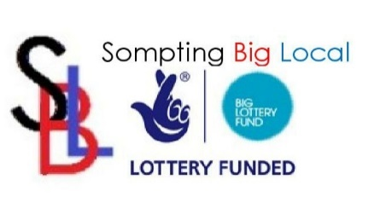
Sompting Big Local Partnership Member Application Form.

Name
Address:
Post Code
Phone Number
Mobile Number
Email
Section one: Personal Details
Contact Information for Big Local use only
Which of the following Priority areas are you most interested in? (tick all that apply)
Health and Well Being |  | Activities |  | Money Matters
Parks & Open Spaces |  | Facilities |  | Young People

When would be the best time for you to attend meetings?
Morning |  | Afternoon |  | Evening

Do you belong to any other local group or organisation?
Yes |  | No

What skills can you bring to the Sompting Big Local Partnership?

Section two: Programme and Partnership Skills
What skills or Knowledge do you have? Or what would like to learn more about? (tick all that apply)
 | None | Some | A lot | Would like to learn more | Could help teach others
Working on the project to improve your local community
Applying for funding
Developing community projects
Project management
Doing consultation with resident
Managing consultation processes
Equality and diversity
Working in partnership (with councils, police, housing associations etc)
Knowledge of how the local council works
Marketing and PR
Knowledge of local community
Knowledge of voluntary sector
Monitoring and evaluation

Section three: Other skills
What skills or Knowledge do you have? Or what would like to learn more about? (tick all that apply)
 | None | Some | A lot | Would like to learn more | Could help teach others
Chairing meetings
Providing secretarial duties e.g. taking minutes, writing reports
Role of Treasurer
Speaking in public
Setting agendas
Minute taking
Giving your opinions
Conflict resolution
Writing reports
Able to drive minibus on a D1 licence

